
NFE2L2 (E79K)
Catalog Number: CR-M26337
Gene Symbol: NFE2L2, NRF2
Description: Anti-NFE2L2 (E79K) Mouse Monoclonal Antibody

Background: NFE2L2 protein is encoded by
NFE2L2 gene. It is a basic leucine zipper protein that regulates the expression of antioxidant
proteins that protect against oxidative damage triggered by injury and inflammation. Several drugs that stimulate the NFE2L2 pathway are being studied for treatment of diseases that are caused by oxidative stress.
Immunogen: A synthetic peptide from the
internal region of NFE2L2 which includes the mutation of E79K, human origin.
Tested applications: ELISA, WB, IHC Recommended dilutions:
ELISA: 1:1000-1:2000
WB: 1:500-1:1000
IHC: 1:50-1:100
Concentration: 1 mg/ml
Host: Mouse
Clonality: Monoclonal
Purity: Purified from ascites
Format: Liquid Storage buffer:
Preservative: no
Constituents: PBS (without Mg2+ and Ca2+), pH 7.4, 150 mM NaCl, 50% glycerol
Species Reactivity: Recognizes E79K mutant, but not wild-type NFE2L2 of vertebrates.
Storage Conditions: Store at -20°C. Avoid freeze / thaw cycles.

Western blot:
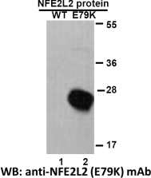

Western blot analysis of recombinant NFE2L2 (E79K) and wildtype proteins. Purified
His-tagged NFE2L2 (E79K) protein (lane2) and corresponding wild-type protein (lane1) were
blotted with anti-NFE2L2 (E79K) monoclonal antibody (Cat. #26337).

For research use only. Not for diagnostic or therapeutic applications.

Immunofluorescence:
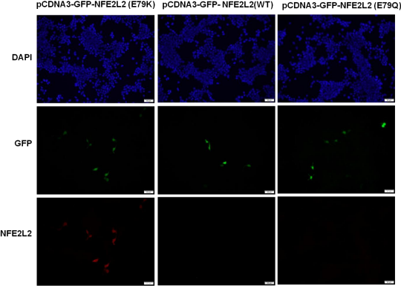
Immunofluorescence of cells expressing NFE2L2 proteins with anti-NFE2L2 (E79K) antibody. HEK293T cells were transfected with pCDNA3-GFP-NFE2L2 (E79K) plasmid,
pCDNA3-GFP-NFE2L2 (WT) plasmid, or pCDNA3-GFP-NFE2L2 (E79Q) plasmid, then fixed and stained with anti-NFE2L2 (E79K) monoclonal antibody (Cat. #26337).

科博瑞（武汉）生物科技有限公司
TEL：027-87615885 15972062685
- mail：3636901710@qq.com
Web:www.coburybio.com

